Assignment:- 6B
4-Bit Asynchronous DOWN Counter using 74LS76

This circuit is designed to function as a 4-bit asynchronous down counter. It utilizes four J-K f lip-flops in a ripple configuration. Unlike an up counter, the inverted output () of each flip-flop is used to clock the subsequent flip-flop, causing the count to decrement with each applied clock pulse The counter cycles downwards from a maximum value of 1111 (15 in decimal) to a minimum of 0000 (0 in decimal). Upon reaching 0000, it will roll over to 1111 on the next clock pulse and continue the sequence.

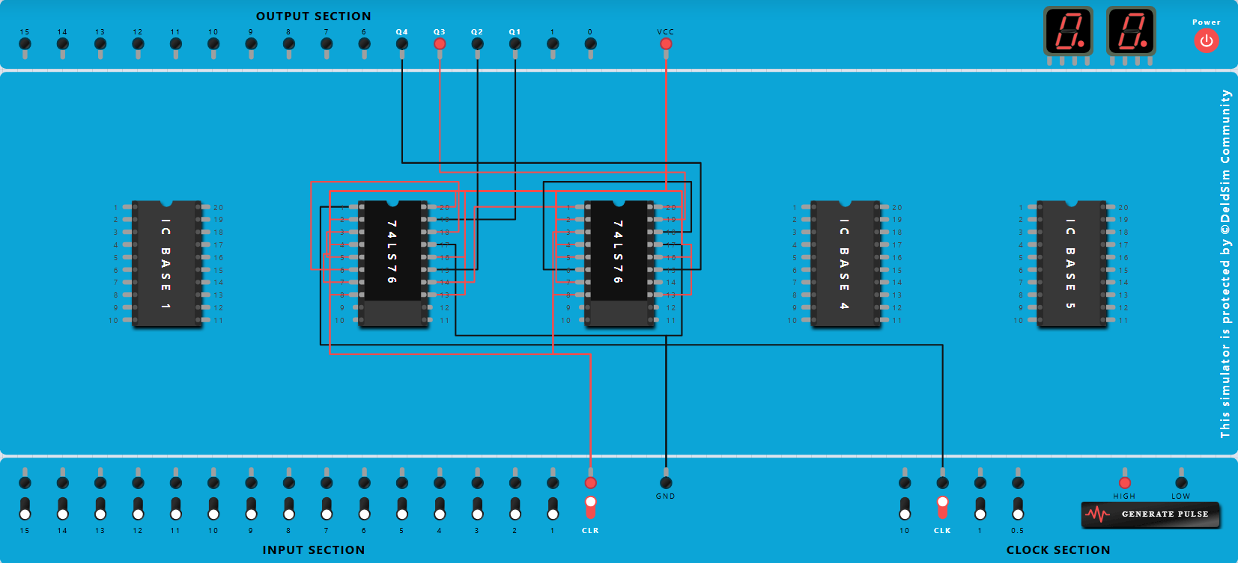
The simulations confirm the correct functionality of the 4-bit asynchronous down counter. The circuit successfully decrements its count, validating the design where the outputs are cascaded to trigger subsequent flip-flops.

